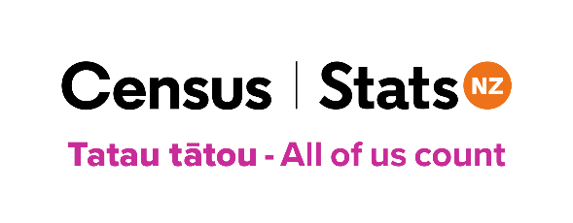
2023 Census Factsheet
Variation of Sex Characteristics (Intersex)
January 2023
Publishers note: This information was created by Stats NZ in consultation with Intersex Aotearoa. It can be shared or reproduced with appropriate references made.
Introduction
The New Zealand Census of Populations and Dwellings is the official five-yearly nationwide survey of everyone in Aotearoa New Zealand and the places they live or stay.
Census Day is Tuesday, 7 March 2023.
For the first time, the census will ask questions about gender, sexual identity, and variation of sex characteristics (generally known as intersex).
It’s important that the census represents all the people of Aotearoa New Zealand. The collection of this information will enable groups and individuals to use census data to advocate for their needs, the same as for every New Zealander.
By taking part in the census, you help create a better understanding of your community and what it needs. People’s responses are combined to produce statistics that provide a picture of life in Aotearoa New Zealand and how it is changing.
Just as for other information collected in the census, it will be important to get good quality responses to these new questions to ensure that the data is able to be used by communities and decision makers.
It will be the first time that groups like Intersex Aotearoa, who advocate on behalf of the intersex community, will be able to have access to anonymised information that can help them better determine their community’s needs.
Intersex
Intersex refers to a person who was born with genetic, hormonal, or physical sex characteristics that do not typically fit within social or medical expectations of female or male bodies. Having a variation of sex characteristics is often referred to as being intersex or having an intersex variation.
These variations may be present from birth or become evident at puberty or later in adulthood.
There are up to 40 different known intersex variations and around 2.3 percent of people worldwide are born with variations of sex characteristics.
Healthcare professionals use medical terms to describe different variations, such as Klinefelter Syndrome, Congenital Adrenal Hyperplasia, or Androgen Insensitivity Syndrome. The umbrella term used within healthcare is DSD, or differences in sex development, or more recently, VSC, or variations of sex characteristics.
While some people born with a variation of sex characteristics will identify as intersex, others do not use that term to relate to themselves.
Having an intersex variation has no relation to a person's gender identity or sexual orientation.
Variations in sex characteristics are normal and natural, and are evident in plants and animals, as well as humans.
Completing the census
The question on variation of sex characteristics in the census asks ‘Were you born with a variation of sex characteristics (otherwise known as intersex variation)?
The response options are:
- yes
- no
- don’t know
or
- prefer not to say.

The census only asks if you have a variation, not what that variation is.
Census forms can be filled out online or on paper. From mid to late February 2023, every household will be sent a census pack with information about how to complete the census.
You can complete your census form at any time during the census period.
If completing your census form online, no one else in your household will be able to view it once you submit it. You will know it has been submitted securely when you see ‘Done’ beside your form on the ‘Household overview’ page.
Once submitted, your information is stored on a secure data storage server certified for use by the New Zealand Government.
Published census data is always about groups and communities, never individuals. All identifying information, such as names and addresses, is removed before anyone can use the data.
Find out more about census
Visit our website www.census.govt.nz, and www.census.govt.nz/contact-us for contact details.
For more information about the Intersex community please visit www.intersexaotearoa.org.

