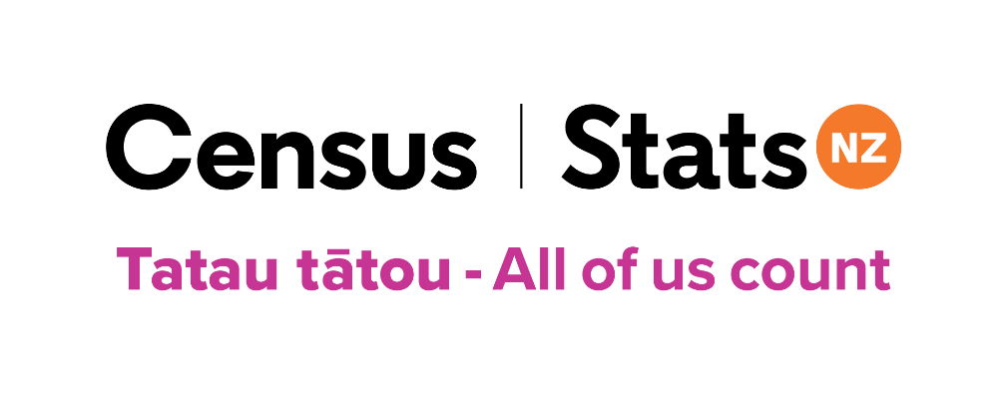
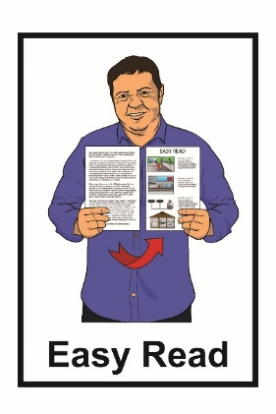

An Easy Read guide to doing

your 2023 Census
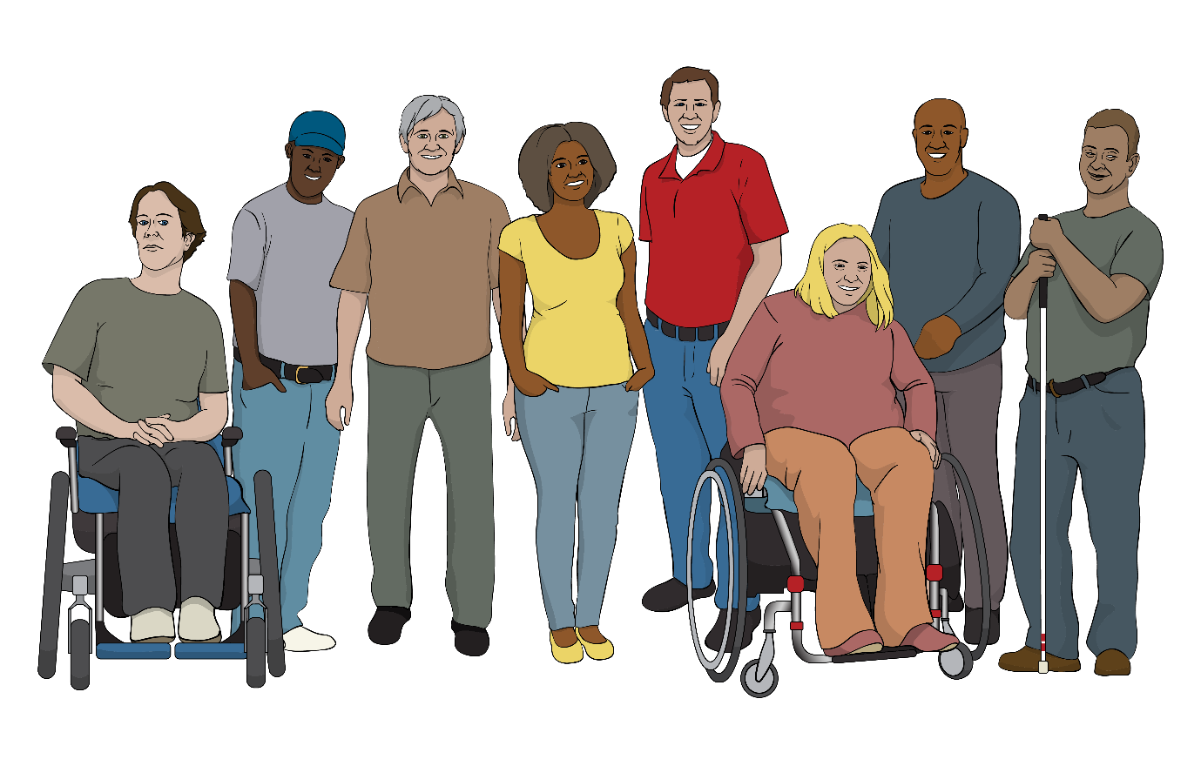

Tatau tātou – All of us count

What you will find in this booklet

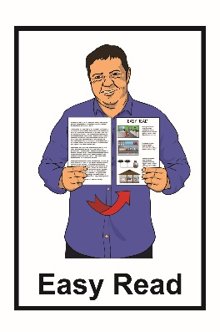
Page number:

What this booklet is about……….…4

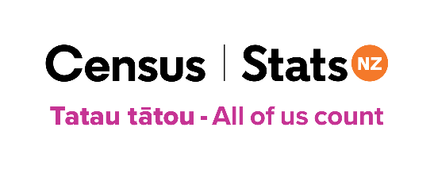
What is the census? ..7

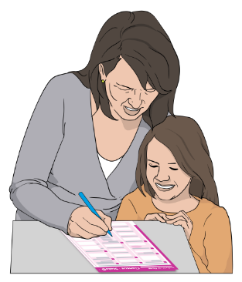
Who needs to fill out
the census? 9

Getting support to fill out the
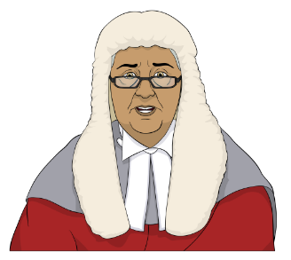
census forms………………………..11

What happens if I do
not fill out my census forms? 15
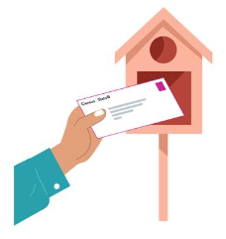

How you will get your
census forms 16

Page number:

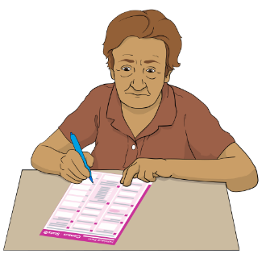
When to fill out your census
forms 19

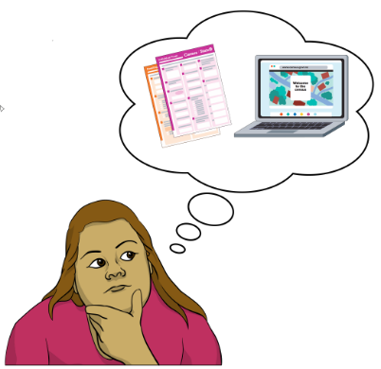
The census forms 20

Before you start your census 24

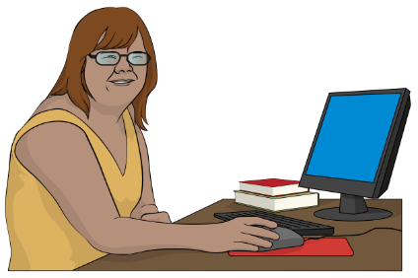
What you need to fill out
your census forms online 25

Filling out your census forms
online 29
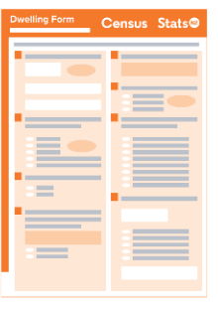
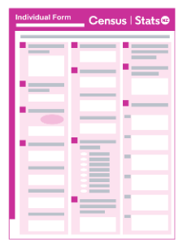

Filling out your census paper
forms 35

Page number:

Returning your census paper
forms 39
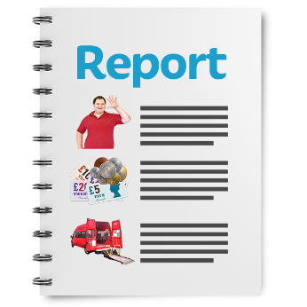

What we do with your
information 40

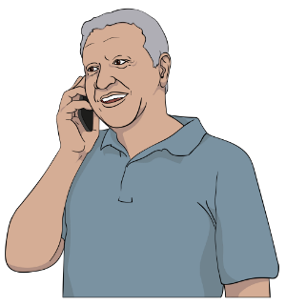
How to contact the census team 42

What this booklet is about

This Easy Read booklet is about the 2023 Census.

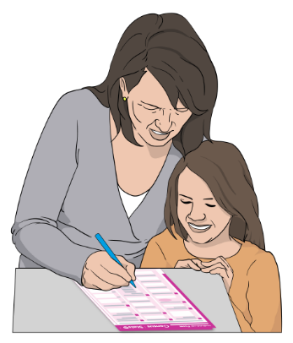
A census is when you are asked questions about things like:
- who you are
- how many people you live with.

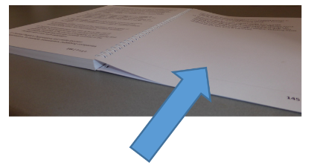
You can find more information about what the census is on pages 7 to 8 of this booklet.

The information has been written by Stats NZ.

Stats NZ is the government agency that runs the 2023 Census
This is a long booklet.

While it is written in Easy Read it can be hard for some people to read a booklet this long.

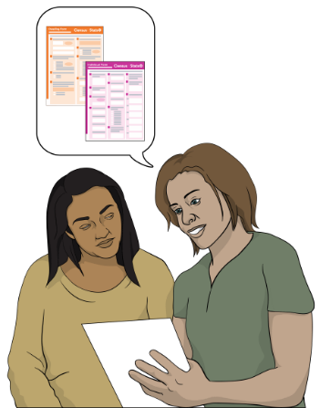
Some things you can do to make it easier are:

- read a few pages at a time

- have someone support you to understand it.

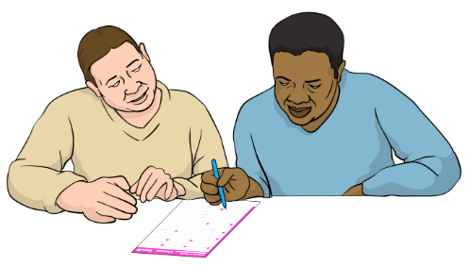
You can ask someone like:
- a friend
- a family member.

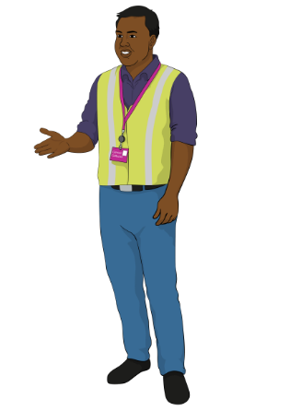
You can also ask for a census collector to support you to understand this booklet.

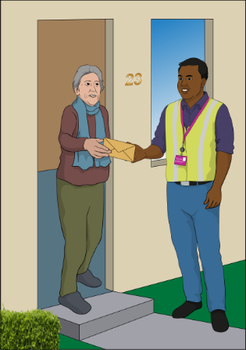
A census collector is someone who may be able to:

- come to your home

- support you to understand the information in this booklet

- support you to fill out your census forms.
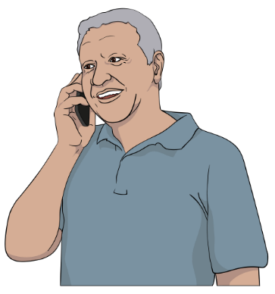
To ask for a census collector to support you to fill out your census forms talk to the census team.

On pages 42 to 44 in this booklet you can find information about how to talk to the census team.

What is the census?

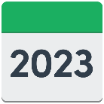
The census is:

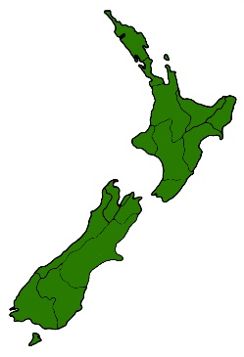
- done every 5 years

- how we find out things about people in New Zealand.

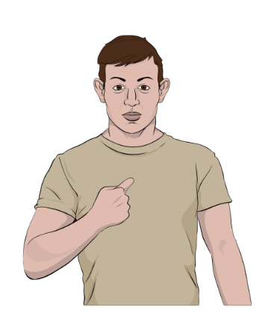
The census is done by using some forms that asks questions about:
- you
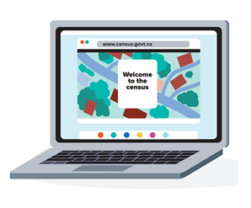
- where you live.

You can do the census by filling out:

- online forms

or

- paper forms.
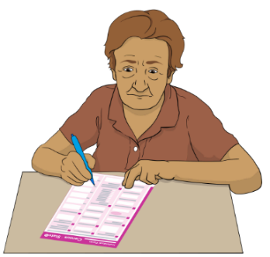
You can choose which form you want to fill out.

The questions in the online / paper census forms are the same questions.

The things Stats NZ find out in the census are used to plan things like:
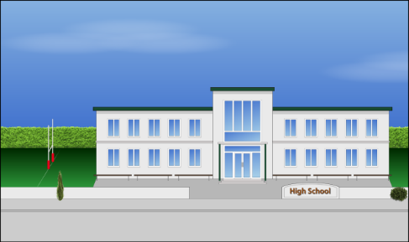
- healthcare
- schools
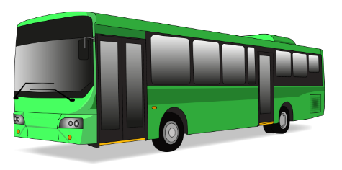
- housing
- public transport like buses
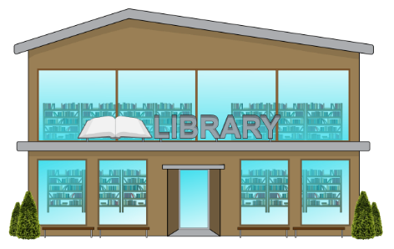
- building roads

- community buildings like libraries.

Who needs to fill out the census?

The law says everyone in
New Zealand needs to fill out the census.

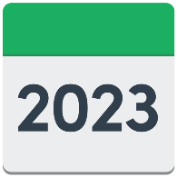
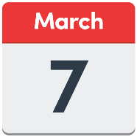
Census day is Tuesday 7 March 2023.

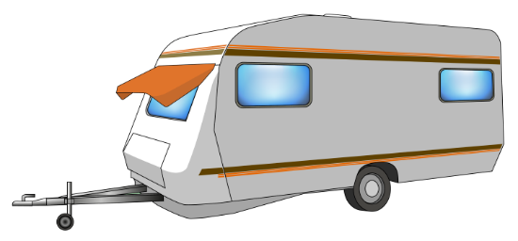
You still need to fill out the census if you:

- live in a place that is not a house
- are in hospital
- do not have an address
- live in a group home

- are visitors to New Zealand.

If you have children then you need to fill out their forms for them.

Getting support to fill out the census forms

If you need support to fill out the census forms you can ask someone like a:
- friend
- family member
- census collector.

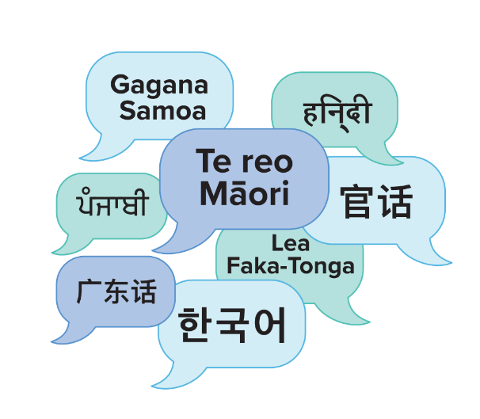
If you speak a language that is not English then you can ask for someone who speaks:
- Te reo Māori
- Samoan
- Tongan
- Mandarin.
If you speak a language that is not English then you can also ask for someone who speaks:
- Cantonese

- Korean

- Hindi
- Punjabi.

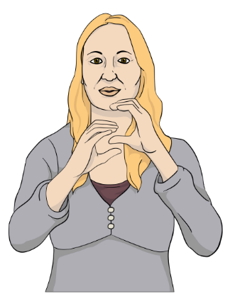
You can find information about the census in New Zealand Sign Language on our website:

www.census.govt.nz

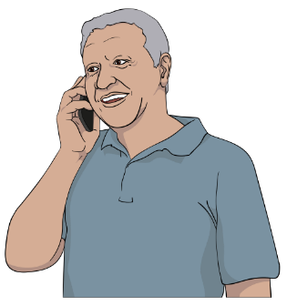
You can contact the census team to ask for a census collector to support you.

On pages 42 to 44 in this booklet you can find information about how to talk to the census team.

If you find it hard to use the phone the New Zealand Relay service is for people who:

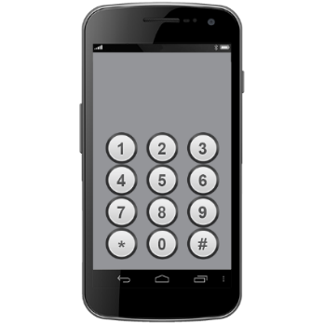
- are Deaf / hard of hearing

- are deafblind

- speech impaired / find it hard to talk.

You can find out more about the New Zealand Relay service at:

www.nzrelay.co.nz

What happens if I do not fill out

my census forms?

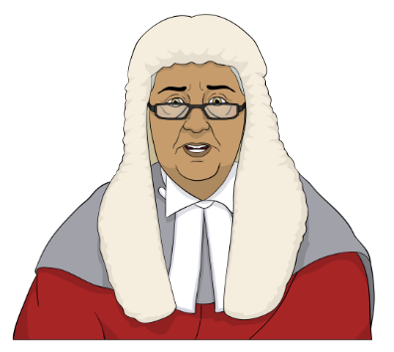
If you do not fill out your census forms then you might:
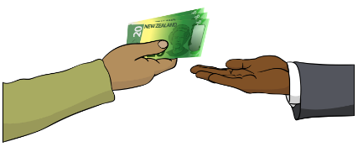
- be taken to court
- need to pay a fine of up to
2 thousand dollars / $2000.
A fine is money that you pay to the government for breaking the law.

How you will get your census forms
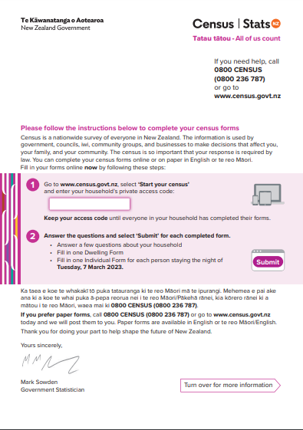
You will be sent a letter about the census.

In some places we will visit your home to give you:
- a letter
- your census forms.

We will either:

- put them in your mailbox
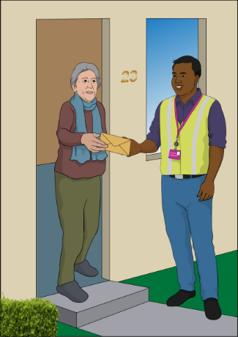
or
- knock on your door to give them to you.

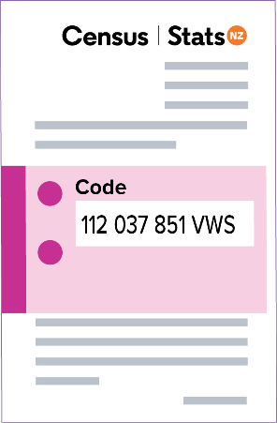
Some people will just be sent a letter with an access code.

An access code lets you fill out the census forms online.

Your access code will be made up of:
- letters
112 037 851 VWS
- numbers.
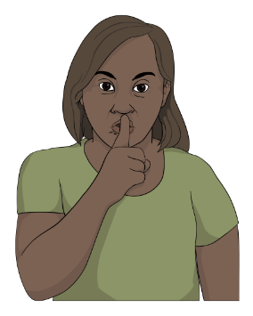

Do not share this access code with anyone who does not live with you.

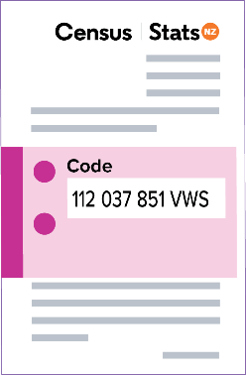
You need to keep the letter with your access code in a safe place.

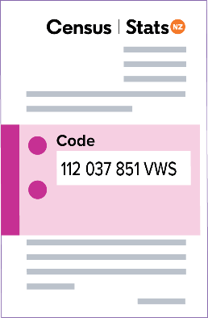
You also need to keep your access code until everyone in your household has completed their forms.

If you do not want to fill out the census forms online then you can contact the census team.

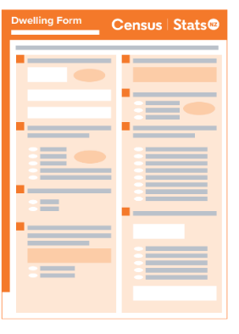
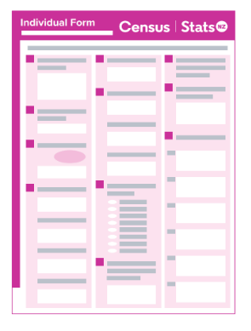
The census team can send you paper forms if you ask for them.

The 3 paper forms you can choose from are in:
- English
- English and Te reo Māori
- Large Print in English.

When to fill out your census forms

You can fill out your census forms any time before Tuesday 7 March 2023.

If you do not fill out your census forms then we will send you a letter to remind you to fill them out.

In some parts of New Zealand we will visit you to:
- remind you to fill out your census forms
- ask if you need support to fill out your census forms.

The census forms
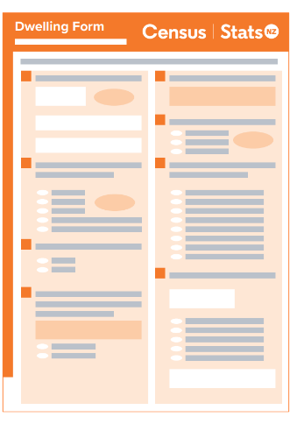
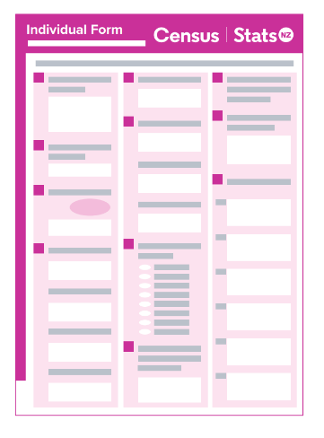

There are 2 census forms you need to fill out:

- Dwelling Form

- Individual Form.

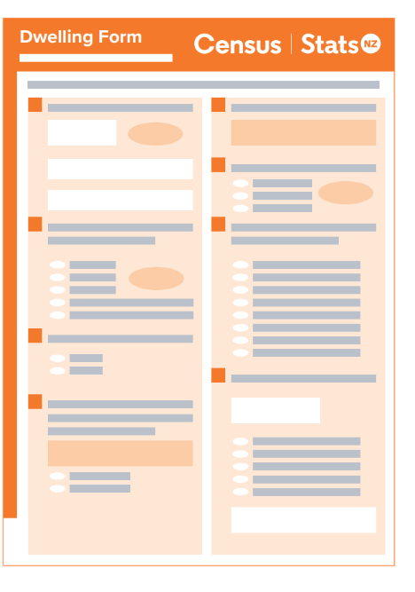
The Dwelling Form tells us about where you live.

A dwelling is a place someone lives like a:
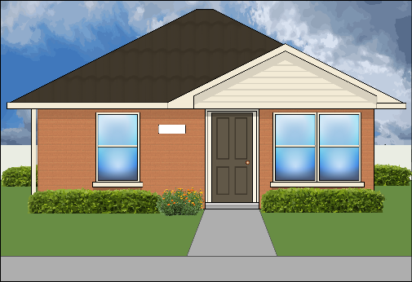
- house
- caravan
- tent.

The Dwelling Form asks questions like:
- how many bedrooms does your home have?
- does your home have the internet?

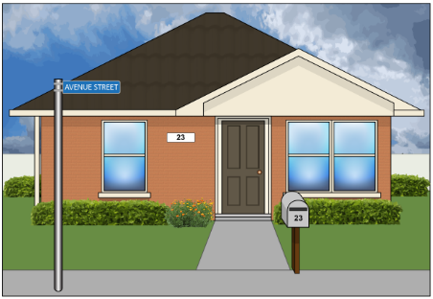
Some people have more than one dwelling where people live at the same address like:

- a house
and

- a caravan / sleep out / granny flat.
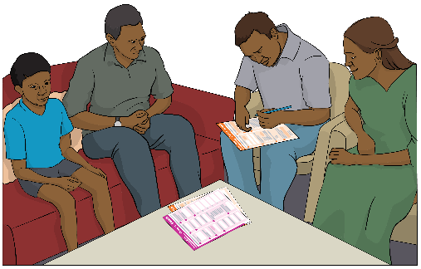

1 person from each dwelling needs to fill out the Dwelling Form.

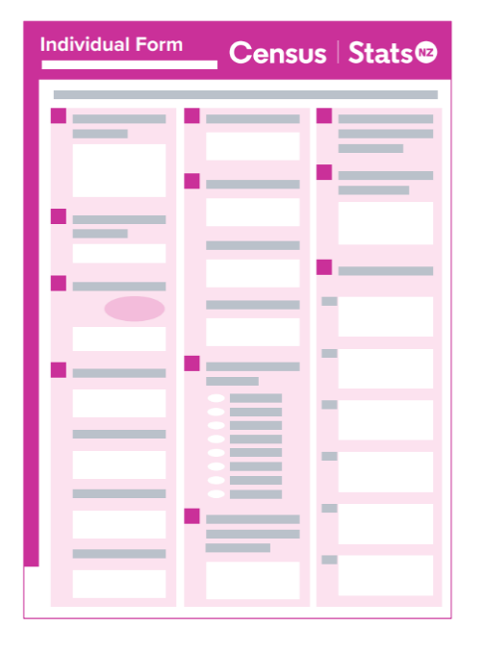
The Individual Form tells us information about you.

The Individual Form asks questions about you like:
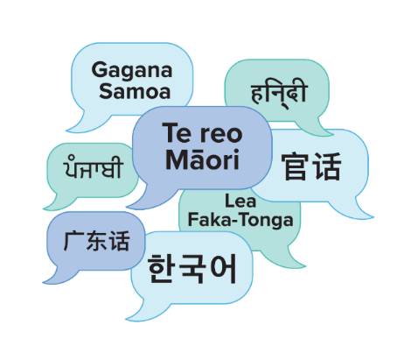
- where you were born?
- what languages do you speak?

- do you study / work?
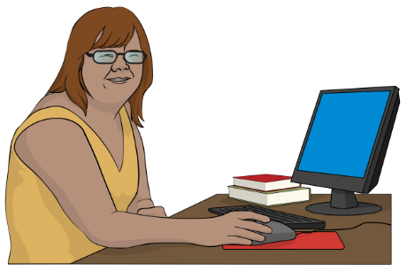
- how much money do you get paid?

- what transport do you use to get to study / work?

- are you in a relationship?

Everyone who lives in your home will:

- have their own Individual Form to fill out

- use the same access code.

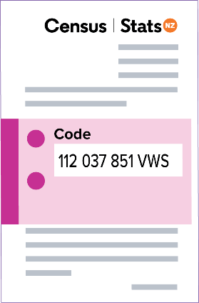
Keep your access code until everyone in your household has completed their forms.

Before you start your census

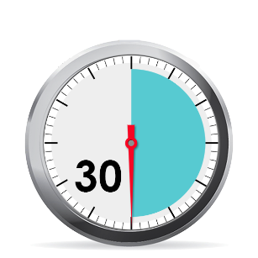
You need at least 30 minutes to fill out your census forms.

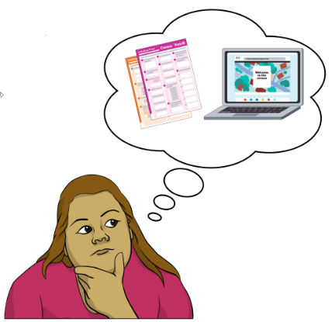
You need to choose if you want to fill out the census forms:
- online
- on paper.

What you need to fill out your

census forms online

If you want to do the census online then you will need a device that can use the internet like a:
- smartphone
- laptop
- tablet.

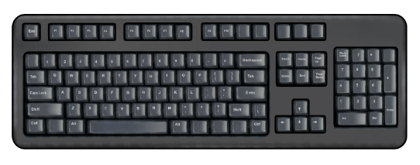
You will also need:
- something to type with like a keyboard
- to be connected to the internet
- your access code.

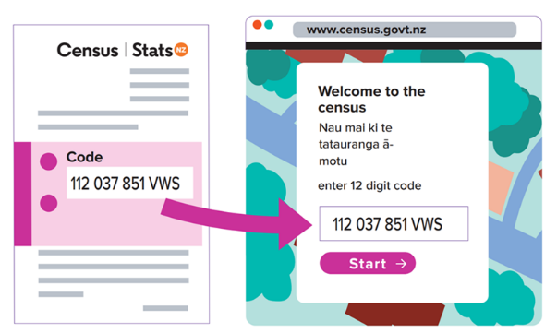
Your access code is on the front of the census letter.

Your access code will be made up of:
- letters
- numbers.

Your access code is for your household only.

Do not share this access code with anyone who does not live with you.

You can share this code with someone who does not live with you if they are supporting you to fill out the census form online.

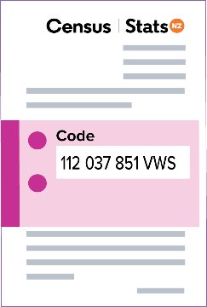
Keep your access code until everyone in your household has completed their forms.

Every house at the same address will need its own access code.

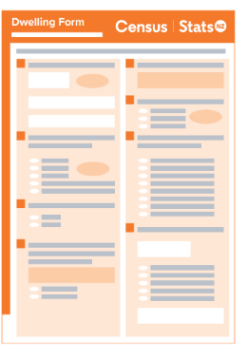
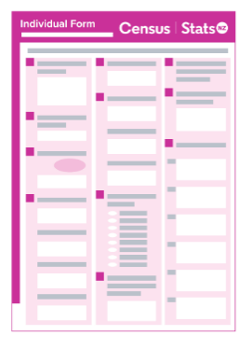
If you have another house / caravan / flat at your address that someone sleeps in it will need its own:
187 069 257 HYT

- access code

- census forms.

If you need another access code then you can use the form on the census website called:

Request an access code.

The census website is:

www.census.govt.nz

You can also call the census team to ask for another access code:

Phone: 0800 236 787
This phone line will be open from Tuesday 7 February 2023.
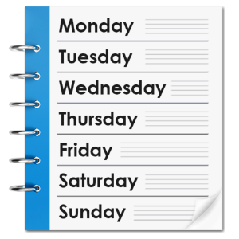

The phone line will be open:

- 7 days a week / everyday
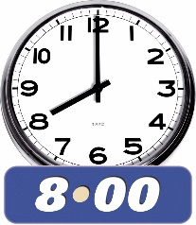
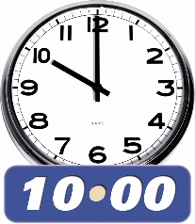
- 8 am in the morning to 10 pm at night.

Filling out your census forms online

To fill out your census forms online you need to open an internet browser on your device.

An internet browser is a program that lets you use the internet.

Browsers are programs like:

- Google Chrome
- Microsoft Edge
- Safari.

You need to use your internet browser to go to the census website at:

www.census.govt.nz

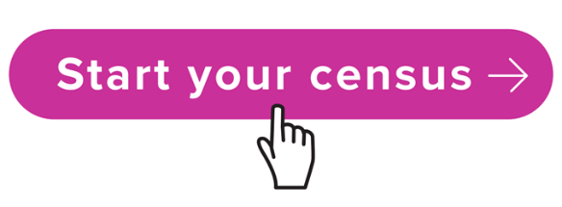
On our website you will see a button that says Start your census.

Click the Start your census button.

You will then be asked for your access code.
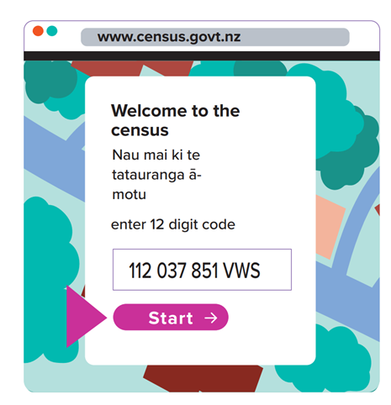

Type your access code into the box on the screen.

Click the Start button to start filling out your census forms.

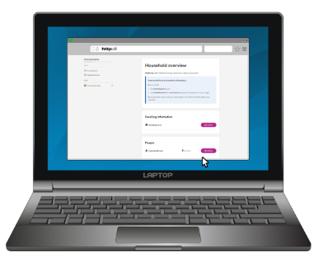
For the online forms you need to choose 1 person who lives in your home to fill out the Household Setup Form.

The Household Setup Form tells us:
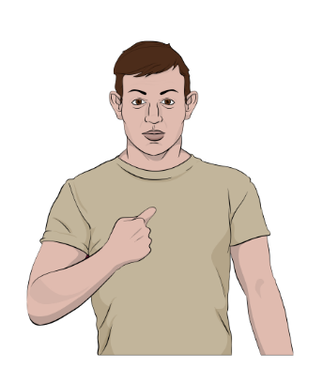
- what your address is
- the names of everyone who lives in your house.

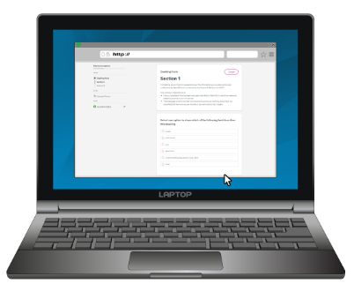
The Household Setup Form needs to be finished before filling out the:
- Dwelling Form
- Individual Forms.

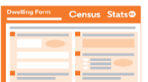

When the Household Setup Form is finished click the button that says Submit.

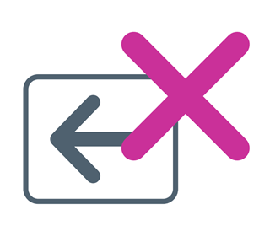
Once you click the Submit button you cannot:
- change your answers
- read your answers.

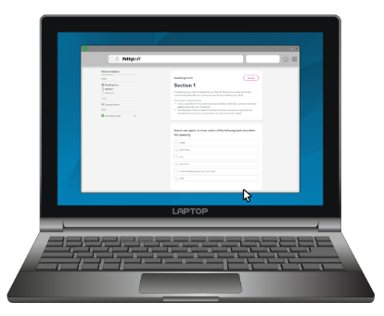
You need to choose 1 person who lives in your home to fill out the Dwelling Form.

This could be the same person who filled out the Household Setup Form.

When they have finished filling out the Dwelling Form they need to click the button that says Submit.
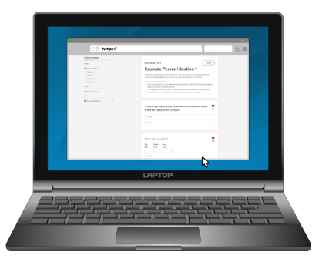
You can start to fill out the Individual Form if you or someone in your house has already finished the:
- Household Setup Form
- Dwelling Form.

When you have finished filling out your Individual Form you need to click the button that says Submit.
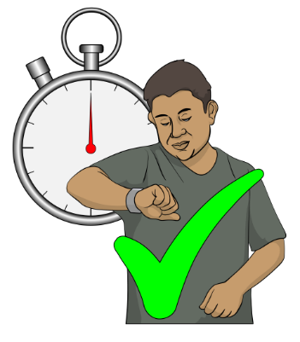

Try to finish the form without stopping if you can.

If you need to take a break make sure you do not close the webpage the census form is on.

You will need to start the census form again if you close the webpage.
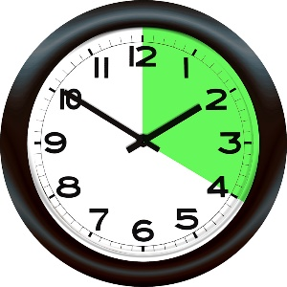
You cannot take a break for more than 20 minutes.

If you take a break for more than
20 minutes then the form will not save what you have typed.

This means you will need to start the census form again.

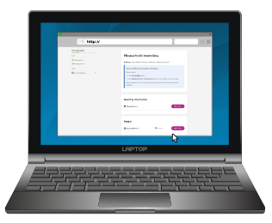
You have finished the census when you have submitted all 3 forms:
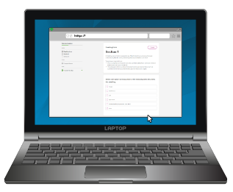
- Household Setup Form

- Dwelling Form
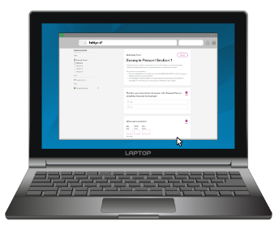
- Individual Form.

Filling out your census paper forms

When you fill out your paper census forms only use a pen that is:

- black

or

- blue.

You need to write your answers in either:
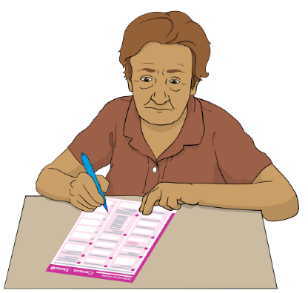
- English

or

- Te reo Māori.

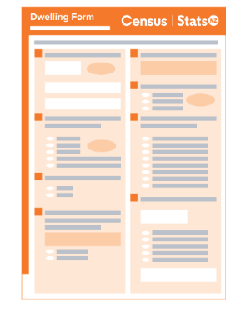
When you fill out your census paper forms you also need to:

- write everything in CAPITAL letters for example:
YOUR NAME

- mark questions with a hyphen or a dash which looks like this:

–

Please do not mark the census forms using:

- ticks /

- crosses / x

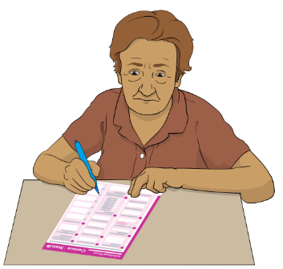
When you fill out your census paper forms you also need to:

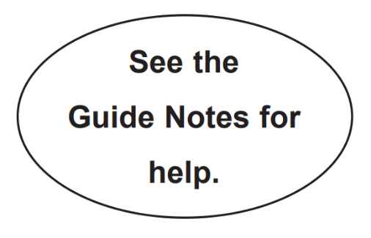
- read every question

- answer every question

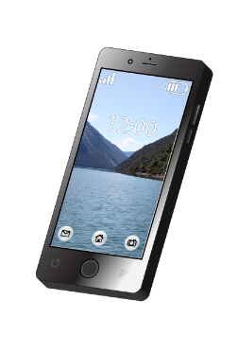
- read the Guide Notes if you are unsure what to do

- write your phone number on the form

- sign your name at the end of the form.

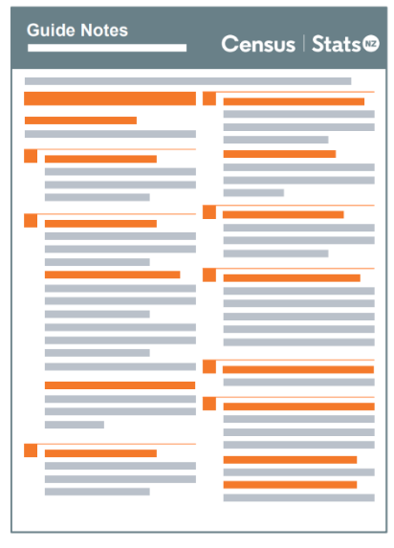
Guide Notes is a small booklet that has information about how to do the census forms.

If someone supported you to fill out your paper forms they can sign the form for you.

We will use the phone number you write down to contact you.

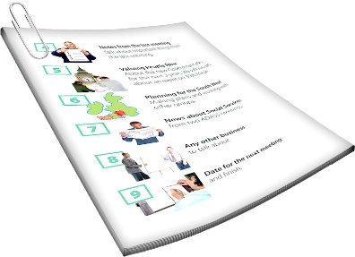
We will use this phone number if we need to ask you to take part in another survey that happens after the census like the New Zealand Disability Survey.

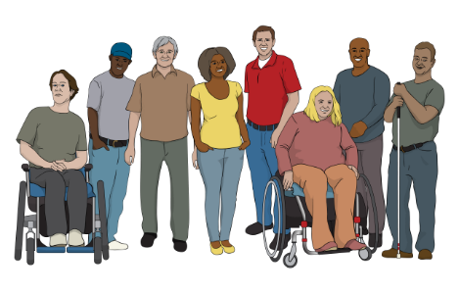
The New Zealand Disability Survey finds out things about disabled people.

You can read more about the New Zealand Disability Survey on our website at:

www.stats.govt.nz/topics/disability

Returning your census paper forms

We will send you a freepost envelope with your paper forms.

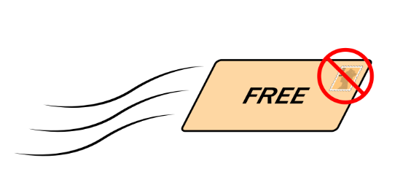
A freepost envelope is an envelope that lets you send mail without having to pay for a stamp.

You can contact the census team if you need a census collector to pick up your census forms.

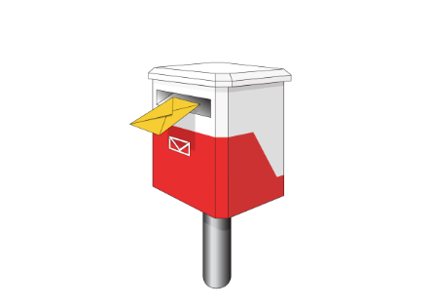
You have finished your census when the 2 forms have been:
- posted to census
- picked up by a census collector.

What we do with your information

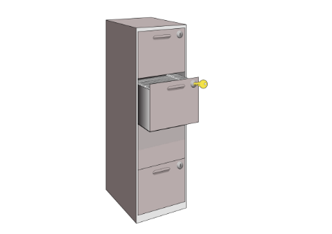
New Zealand law says that anything you tell us must be kept:
- private
- safe.

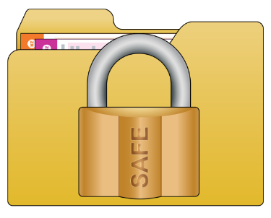
Private means that we will not share any of your personal information with other:
- people
- groups.

Personal information means things about you like your name.

Stats NZ will use the things found out from the census to write statistics about communities in New Zealand.

Statistics are numbers that tell us things like how many:
- people live in a city
- children go to a local school
- people in New Zealand have a disability.

When we let other people read our statistics we make sure no one can:
- know who you are
- know what you answered in the census.

How to contact the census team

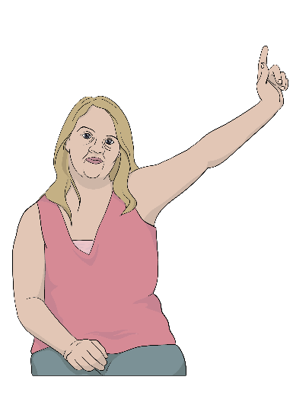
You can contact the census team if you:
- have any questions
- need census paper forms
- would like a census collector to support you.
You can contact us by Freephone on:

0800 236 787

Freephone means that this number will not cost you any money to call.

This phone line will be open from Tuesday 7 February 2023.

The phone line will be open:

- 7 days a week / everyday
- 8 am in the morning to 10 pm at night.

You can also visit our website at:

www.census.govt.nz

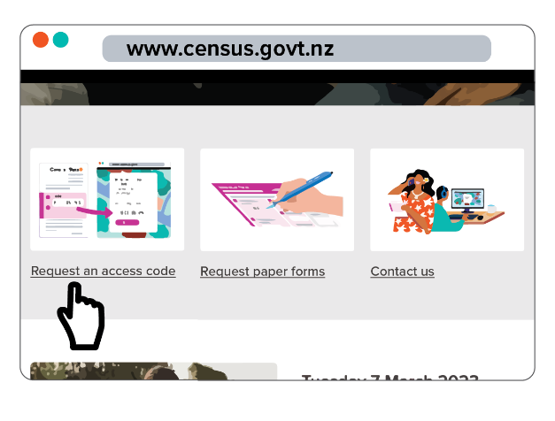
On our website you can:

- get a new access code by clicking on: Request an access code

- ask for paper census forms by clicking on: Request paper forms

- ask questions by clicking on: Contact us.

This information has been written by Stats NZ.

It has been translated into Easy Read by the Make it Easy Kia Māmā Mai service of People First New Zealand Ngā Tāngata Tuatahi.

The ideas in this document are not the ideas of People First New Zealand Ngā Tāngata Tuatahi.
Make It Easy uses images from:

- SGC Image Works

- Photosymbols.com.

This booklet also uses images supplied by Stats NZ.

All images used in this Easy Read document are subject to copyright rules and cannot be used without permission.

